INTRODUCTION

Project Overview
The school IT helpdesk receives multiple incident requests daily from students and teachers, such as Wi-Fi issues, projector failures, password problems, and slow computers.
Currently, IT staff manually reviews each request and assigns a category, which is time-consuming and inefficient.
This project automates ticket classification using ServiceNow Flow Designer by analyzing keywords in the incident’s short description and description fields.

Purpose
The main purpose of this project is to automate the classification of IT helpdesk incident tickets using ServiceNow Flow Designer.
The specific purposes are:
- To automatically identify the type of IT issue.
- To analyze keywords from the ticket's Short Description and Description.
- To automatically assign suitable category and subcategory values.
- To reduce the manual effort required from IT helpdesk staff.
- To provide consistent classification of incident tickets.
- To improve the efficiency of the ticket management process.
- To make the classification process more scalable when the number of tickets increases.

2. IDEATION PHASE

2.1 Problem Statement
The school IT helpdesk receives a large number of incident requests from students and teachers every day. These requests are related to various technical issues such as Wi-Fi connectivity problems, projector failures, password and account access issues, slow computers, and other system-related problems.
At present, IT staff manually examine each incident request and determine the appropriate issue type, category, and subcategory. They also need to communicate with the caller regarding the creation and processing of the ticket. As the number of requests increases, this manual process becomes time-consuming and may result in inconsistent classification.
The absence of an automated classification mechanism can lead to:
- Increased workload for IT helpdesk staff.
- Delays in processing incident requests.
- Incorrect or inconsistent category selection.
- Repeated manual checking of ticket descriptions.
- Difficulty in handling a large number of tickets efficiently.
- Reduced productivity of IT support staff.

Proposed Problem Solution
To overcome these challenges, the project proposes an Auto Ticket Classification system using ServiceNow Flow Designer. The system analyzes keywords available in the Short Description and Description fields of an incident ticket.
Based on predefined keywords, the Flow Designer automatically identifies the type of issue and assigns the appropriate category and subcategory.
For example:
- A ticket containing “Wi-Fi” or “internet” can be identified as a network-related issue.
- A ticket containing “projector” or “HDMI” can be classified as a hardware-related issue.
- A ticket containing “password” or “login” can be identified as an account-access issue.
- A ticket containing “slow computer” or “system lag” can be classified as a performance-related issue.
Thus, the proposed solution aims to reduce manual effort, improve classification consistency, and make the school IT helpdesk ticket-handling process more efficient.

2.2 Empathy Map Canvas
The Empathy Map Canvas is used to understand the needs, difficulties, and expectations of the people involved in the IT helpdesk ticket-management process.
For this project, the primary user is the IT Helpdesk Staff, while students and teachers are the users who submit incident requests.

Empathy Map – IT Helpdesk Staff
Section | Description
Says | “There are too many tickets to classify manually.” / “Some tickets are difficult to categorize.”
Thinks | “Can ticket classification be automated?” / “I need to process tickets quickly and accurately.”
Does | Reviews ticket descriptions, identifies keywords, selects category and subcategory, and processes the incident.
Feels | Overloaded when many tickets arrive at the same time and concerned about classification errors.
Pains | Manual classification, repetitive work, incorrect categorization, delays, and increasing workload.
Gains | Automatic classification, reduced workload, faster processing, consistent categorization, and improved productivity.

Empathy Map – Students and Teachers
Section | Description
Says | “My Wi-Fi is not working.” / “I cannot log in.” / “The projector is not working.”
Thinks | “I want my issue to be identified correctly.” / “I need support quickly.”
Does | Reports the technical issue by creating an incident ticket.
Feels | Frustrated when the issue takes a long time to process or is incorrectly categorized.
Pains | Delayed support, incorrect ticket classification, and repeated communication with the helpdesk.
Gains | Faster ticket processing, accurate classification, and efficient IT support.

Key Insights from Empathy Mapping
The empathy analysis identifies the following important requirements:
- Ticket classification should require minimal manual effort.
- Common IT issues should be automatically recognized.
- Category and subcategory selection should be consistent.
- The system should reduce the workload of IT helpdesk staff.
- Students and teachers should receive faster support.
- The solution should be capable of handling an increasing number of incident requests.

2.3 Brainstorming
Brainstorming was conducted to identify possible solutions for improving the school IT helpdesk ticket-classification process.
The main objective was to find a solution that could automatically identify common IT issues from the information provided in an incident ticket.

Brainstorming Ideas
No. | Idea | Description
1 | Manual Classification | IT staff manually review every ticket and select the category and subcategory.
2 | Keyword-Based Classification | Identify keywords in the ticket description and assign the appropriate category.
3 | Flow Designer Automation | Use ServiceNow Flow Designer to automatically process and classify incident tickets.
4 | Predefined Classification Rules | Create rules for common issues such as network, hardware, account access, and performance.
5 | Notification Automation | Automatically notify the caller after ticket creation or processing.
6 | AI-Based Classification | Use AI/NLP techniques to understand ticket descriptions and classify complex issues.
7 | Reporting and Analytics | Analyze ticket categories and identify frequently occurring IT problems.

Selected Idea
After considering the different ideas, Keyword-Based Auto Classification using ServiceNow Flow Designer was selected as the primary solution for this project.
The proposed approach uses the following basic workflow:
Incident Ticket Created
↓
Read Short Description & Description
↓
Analyze Keywords
↓
Match Predefined Conditions
↓
Identify Issue Type
↓
Assign Category & Subcategory
↓
Continue Ticket Processing

Example Brainstorming Rules
Keywords | Identified Issue | Category | Subcategory
Wi-Fi, internet, network | Connectivity Issue | Network | Connectivity
Projector, display, HDMI | Projector Issue | Hardware | Projector
Password, login, account | Access Issue | Software | Account/Password
Slow, lag, performance | Performance Issue | Software/Hardware | Performance

Outcome of Brainstorming
The brainstorming process resulted in a solution that focuses on automation, consistency, and reduced manual effort. ServiceNow Flow Designer is used as the automation mechanism, while keyword-based conditions provide the initial classification logic.
The proposed solution is designed to handle common helpdesk incidents efficiently and provides a foundation that can later be extended with more advanced classification techniques.

3. REQUIREMENT ANALYSIS

3.1 Customer Journey Map
The customer journey starts when a student or teacher faces an IT issue and creates an incident ticket.
User → Create Incident → Ticket Received → Flow Designer Analysis → Category/Subcategory Assignment → Email Notification → IT Staff Processing → Issue Resolution
The automated process reduces manual classification and helps the IT team process tickets efficiently.

3.2 Solution Requirement
The system requires:
The project requires the following:
- ServiceNow platform.
- Incident Management module.
- New Update Set for project configuration.
- Configured incident fields.
- Flow Designer for automation.
- Keyword-based classification conditions.
- Automatic category and subcategory assignmen
- Email notification to the caller.
- Testing and validation of the complete workflow.

3.3 Data Flow Diagram

Student / Teacher

↓

Create Incident Ticket

↓

Short Description + Description

↓

Flow Designer

↓

Keyword Analysis

↓

Category & Subcategory

↓

Email Notification

↓

IT Helpdesk Staff

↓

Ticket Resolution
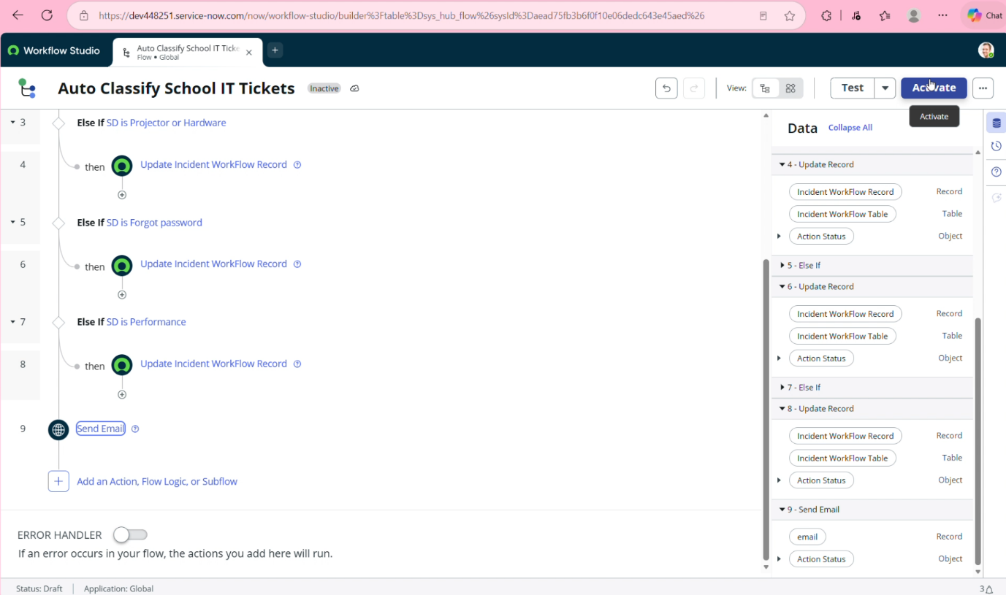

3.4 Technology Stack
Technology / Tool | Purpose

ServiceNow | Main development platform

Incident Management | Create and manage support tickets

Update Set | Maintain project configurations

Flow Designer | Automate ticket classification

Email Notification | Inform the caller about ticket processing

ServiceNow Database | Store incident and configuration data

4. PROJECT DESIGN

4.1 Problem Solution Fit
The proposed system addresses the manual ticket-classification problem by automating the classification process using ServiceNow Flow Designer.
The system:
- Reads the incident description.
- Identifies relevant keywords.
- Assigns the appropriate category and subcategory.
- Sends an email notification.
- Reduces manual effort and processing time

4.2 Proposed Solution
The proposed solution uses a ServiceNow Flow to automatically classify incident tickets.
Process:
Incident Created → Read Description → Check Keywords → Classify Ticket → Update Category/Subcategory → Send Email
This solution provides a simple and automated approach for handling common school IT support requests.

4.3 Solution Architecture
Student / Teacher
↓
Incident Creation
↓
Short Description +
Description
↓
ServiceNow Platform
↓
Flow Designer
↓
Keyword Conditions
↓
Category / Subcategory
↓
Email Notification
↓
IT Helpdesk

5. PROJECT PLANNING & SCHEDULING

5.1 Project Planning
The project was planned and implemented in five milestones. Each milestone focuses on a specific stage of developing the Auto Ticket Classification system.
Milestone | Activities
Milestone 1 | Requirement Analysis, Business Use Case, Update Set Creation and Navigation
Milestone 2 | Backend Development and Configuration
Milestone 3 | Flow Designer Automation and Email Notification
Milestone 4 | Testing, Validation and Security
Milestone 5 | Deployment and Conclusion

Milestone 1: Requirement Analysis & Planning
Activity 1: Business Use Case
Activity 2: Creation of New Update Set
Activity 3: Navigation steps in Picture View

Milestone 2: Backend Development & Configuration
Activity 1: Creation of Custom Table to Store Ticket Records
Activity 2: Field Creation and Data Type Configuration
Activity 3: Implementing Dependency Between Category and Subcategory Choice Fields

Milestone 3: Automation using Flow Designer & Email Notification
Activity 1: Auto Classification using Flow design

Milestone 4: Testing, Validation & Security
Activity 1: Test Scenario 1
Activity 2: Test Scenario 2
Activity 3: Test Scenario 3

Milestone 5: Deployment & Conclusion
Activity 1: Make Update set to Complete State
Conclusion

6.FUNCTIONAL AND PERFORMANCE TESTING

6.1 Performance Testing
The system was tested with different types of IT incident requests to verify whether the Flow Designer correctly identifies keywords and assigns the required category and subcategory.
Test Case | Input Issue | Expected Result | Status
TC01 | Wi-Fi not working | Network category assigned | Pass
TC02 | Projector not working | Hardware category assigned | Pass
TC03 | Forgot password | Account/Password category assigned | Pass
TC04 | Computer running slowly | Performance category assigned | Pass
TC05 | Valid incident with description | Flow executes successfully | Pass

Testing Process
- Create an incident ticket.
- Enter the issue in Short Description/Description.
- Submit the ticket.
- Flow Designer checks the configured conditions.
- Category and subcategory are updated automatically.
- Email notification is generated.
- Verify the final ticket details.

Validation
The testing confirms that the configured automation can classify the predefined incident types and execute the required notification process.

. RESULTS

Output Screenshots
The developed system was successfully configured to automate the classification of IT incident tickets using ServiceNow Flow Designer.
The following screenshots can be included as evidence of the project output:
- Business Use Case / Requirement
  - Shows the identified helpdesk ticket-classification requirement.
- Update Set Creation
  - Shows the new Update Set created for the project.
- Incident Ticket Creation
  - Shows a sample incident with Short Description and Description.
- Flow Designer
  - Shows the configured trigger and classification conditions.
- Automatic Classification
  - Shows the automatically updated category and subcategory.
- Email Notification
  - Shows the notification sent after ticket processing.
- Final Output
  - Shows the complete successfully classified incident.

Result
The system automatically analyzes the incident details and applies the configured classification rules. This reduces manual classification work and provides a consistent ticket-processing workflow

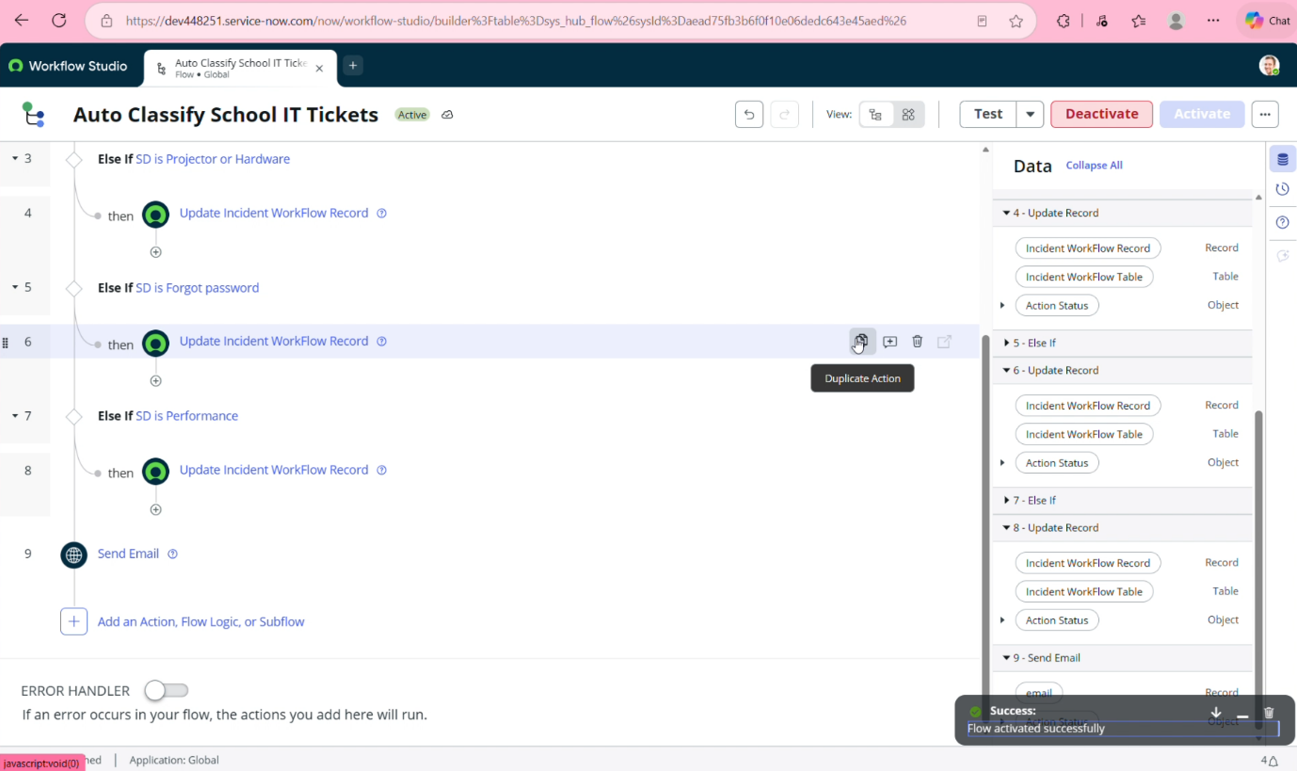
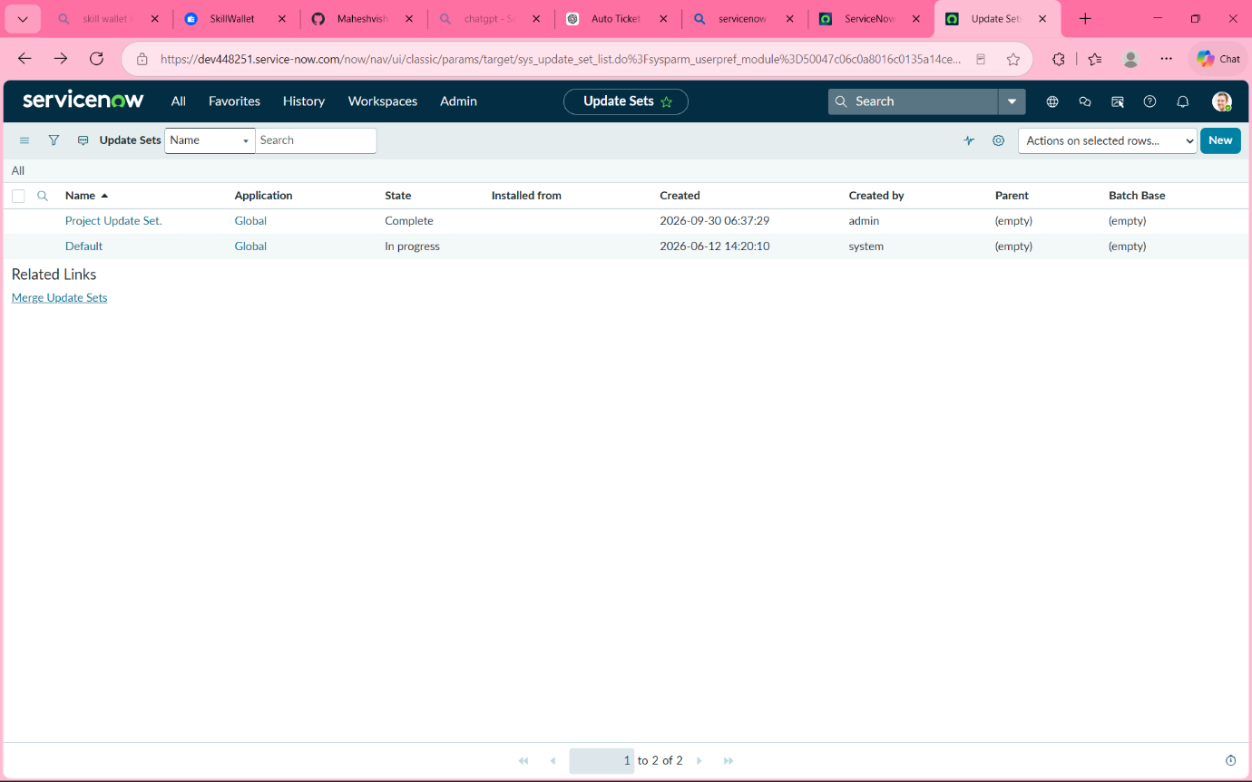

ADVANTAGES & DISADVANTAGES

Advantages
- Reduces manual work by automatically classifying incident tickets.
- Saves time in category and subcategory selection.
- Improves consistency in ticket classification.
- Automates email notifications to the caller.
- Easy to maintain using ServiceNow Flow Designer.
- Scalable for handling a larger number of helpdesk tickets.

Disadvantages
- Classification depends on the predefined keywords and conditions.
- Unrecognized or ambiguous descriptions may not be classified correctly.
- New issue types require additional flow conditions.
- Complex issues may require manual review.

CONCLUSION
The Auto Ticket Classification using Flow Designer project successfully automates the classification of IT helpdesk incident tickets. The system analyzes the Short Description and Description fields and uses predefined conditions to assign the appropriate category and subcategory.
The project also includes Flow Designer automation and email notification, reducing the manual effort required by IT helpdesk staff.
Overall, the solution provides a simple and efficient approach for handling common IT support requests and improves the consistency of ticket classification

FUTURE SCOPE
The Auto Ticket Classification using Flow Designer system can be enhanced in the future with additional automation and intelligent features.
- AI-based classification: Use AI/NLP to understand ticket descriptions beyond predefined keywords.
- More issue categories: Add support for additional IT problems and subcategories.
- Automatic assignment: Assign tickets directly to the appropriate IT staff based on issue type.
- Priority detection: Automatically identify the priority of an incident based on its description.
- Advanced notifications: Send notifications through additional communication channels.
- Analytics dashboard: Analyze frequently reported issues and ticket-resolution trends.
- Continuous improvement: Add new keywords and classification rules based on newly identified issues.
These enhancements can make the system more intelligent, scalable, and useful for future IT helpdesk operations.

Source Code
The project is implemented using ServiceNow Flow Designer. The flow configuration, conditions, incident settings, and notification configuration form the main implementation components.
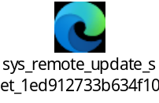

Dataset Link
The project does not require a separate external dataset. The classification is performed using the Short Description and Description fields of ServiceNow incident records with predefined keyword conditions.

GitHub & Project Demo Link

GitHub Repository: https://github.com/sujith12102006aakash-ops/Skill-wallet
Project Demo: https://youtu.be/UHTkssu54OQ

